COMP3000 Final Document
Table of Contents
Introduction 2
Features of the Browser and Why 2
Unique Selling Points 4
Issues / Challenges 4
Testing 5
Design 5
Methodology 8
Database 8

Introduction
- Security focussed browser called Stronghold

- Originally wanted to be aimed towards older people to help to protect them against scams however has since pivoted towards being aimed towards younger people as a “Child’s First Browser” kind of solution

- Will have a gamified aspect to it which will encourage children to use it for browsing and will teach them safe browsing while also having fun using it

- Uses a variety of safety methods to make the browser (and device it is downloaded onto) secure against any kind of attack, as well as mitigating the risk if an attack is successful

- Utilises behavioural conditioning to teach and change behaviours -> By using things like experience points, challenges, quizzes etc. this can help to condition safe behaviours within users as positive behaviours are positively reinforced, whereas negative behaviours are negatively reinforced

The project I have created for this assignment is a security focussed browser which I have called “Stronghold”. The purpose of Stronghold is to encourage children to browse the internet safely, by providing hints and tips as they browse, as well as awarding experience points to users for following these hints. Additionally, there will be games and quizzes which users are able to do to earn bonus experience points and unlock various customisation abilities for their browser. There will be a variety of safety methods which I will implement, all of which will be explained in the following section, to ensure the browser and device are secured against attacks, as well as mitigating the risk should an attack be successful. The audience which I am targeting was originally older people as this was intended to be used to protect them from scams, however I have since pivoted to targeting children and parents to allow Stronghold to be used as a child’s first browser before they are allowed on unrestricted internet with less security.

Features of the Browser and Why
As explained in the introduction, the primary focus of Stronghold is to combine a variety of security features into one place which can be used to help young children learn internet safety. The features which I intend to implement into this project are listed below, followed by my reasoning for implementing these features:
- Session Only Cookies – Prevents cookies from being stored which can help if attacked by something like a cookie scraper (as there will only be cookies from that session therefore limiting what is able to be stolen)

- Strong authentication for exporting cookies or saved passwords – Prevents things such as cookie scrapers from being able to function as they cannot be exported / seen without correct authentication (Based on real-world experience)

- Blocking non-HTTPS sites – Ensures that all sites which are accessed are using secure transmissions and therefore have a higher likelihood of safety

- Scanning files and blocking downloads of typically malicious extensions i.e. .exe files – Prevents any dangerous files from being downloaded accidentally – Since the browser is targeted to children, they shouldn’t really be downloading things anyway without at least their parent’s permission; also means that they can’t be run which takes stress away from needing antivirus

- TLS Certificate Checking – Ensures that websites can be trusted by verifying the connection is secure and encrypted

- Security Based Hints – The main goal of the browser is to encourage safe browsing habits within children, so by including hints and tips when there is a learning opportunity, this will engage their brains to think about what they are doing. Additionally, these hints will tie into the gamification aspect of the browser which should act as a way of engagement too.

- Domain detection –

- Override Methods – Allows the browser to be used by people of all ages, rather than JUST children by giving them an override to download certain file types or access certain restricted websites etc. Also allows parents to give their children possibly temporary access to these features, maybe use something like a limited time request sent to the parent’s email or SMS, or use something like a specific pin (or have them type something like “I ACKNOWLEDGE” with an explanation pop-up so they are at least aware of the risks)

- Possible parental controls –

- Gamification –

- Security Dashboard – This will be a central place that users can navigate to which will store data to determine how secure their browsing habits have been. It will include things like how many times they have overridden blocks, how many times they have attempted to visit blocked sites etc. The dashboard will also be the location of where they can customise the browser, and where they will see how many experience points they have and what level they are. Lastly, this will be where the quizzes and potential games are stored to allow them to gain bonus points for learning about safe browsing

- Quizzes / XP Gain / Cosmetic Unlocks / Games –

Unique Selling Points
- Behavioural conditioning by encouraging positive behaviour through providing rewards such as experience points, and discourages negative behaviour through taking away things such as losing experience points

- Uses a single, consistent method of creating secure browsing without having to download and mess around with multiple extensions and browser features / settings

- Eliminates the issue of conflicting extensions such as websites breaking due to different extensions trying to block different things or false warnings due to other extensions being flagged

- Being used primarily as a teaching tool to allow young children to learn safe browsing before accessing unrestricted internet through other browsers. Teaches about safe internet usage rather than warning or protecting without an explanation as to why like what other browsers (Chrome, Firefox etc.) do

- Has a centralised dashboard which allows users to compare their browsing habits over time and see how they are improving and what behaviours are good

Issues / Challenges
Throughout this project, there are a handful of issues and challenges which I am expecting to face.
- Cannot ethically test against children therefore all testing will be done away from the target audience meaning I cannot get an accurate understanding -> Could test against parents to see if they would let their children use it??

- Motivation / Avoiding burnout – Need adequate time management and need to not push myself too hard, while still being able to get effective work done -> Difficult to manage alongside other modules, especially with Christmas period and the lack of understanding around how Electron works, as well as the amount of features I want to implement -> Need to narrow features down to “must have” (primary focus) and “may have” (if I have time)

- How will I host the server? – Since I want the user to be able to make an account, I will need to host this on a server of some sort to store things like logins, customisation, experience points etc. -> Firebase, Mongoose and SQLite are all options, or alternatively host a local database for this project although in future that will not be secure and defeats the purpose of a secure browser

Testing
- Will get several people to test the browser and answer a Google Form with a variety of questions to get an understanding of what they like and what should change
- Test both initial wireframes (so I can change before proper development begins), and with the final design (so I can make changes before the VIVA and final presentation)
- Form will be tested majority using other students; however, I may also use some non-student friends, family members etc. to get a full, diverse response pool
- Testing form needs to include a declaration to state that respondent is happy for their answers to be included for the purpose of this document and the final submission

Design
Wireframes:
- Home Page:

- Dashboard:

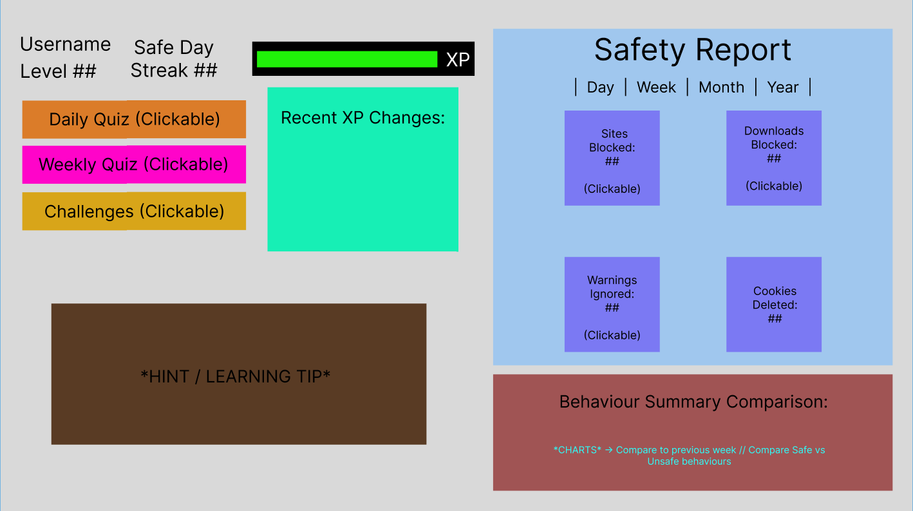

The dashboard will be the main page in which the users can go to discover the gamification aspects of the browser, such as their level and experience points, quizzes and challenges, as well as their safety report to see how safe their browsing is. There will be a variety of clickable elements within the dashboard which will perform the following functions:

- Daily Quiz -> This will allow the user to complete a small, safety-based daily quiz for a small amount of experience
- Weekly Quiz -> This will allow the user to complete a larger, safety-based weekly quiz for a medium amount of experience
- Challenges -> This will give the user several challenges in list form which they can complete while browsing for small amounts of experience
- Sites Blocked -> This will show the user a list of URLs which have been blocked from visiting, along with timestamps and the reason for why it has been blocked
- Downloads Blocked -> This will show the user a list of files which have been blocked from downloading, along with timestamps and the reason for why it has been blocked
- Warnings Ignored -> This will show the user a list of warnings which they have ignored or bypassed, along with timestamps and the reason for the warning initially

At a minimum, I want to implement the experience points features (including levels), the account feature, the hints and the summary report. As a stretch task, I want to aim to implement the behaviour comparison between weeks, as well as the filter for different time periods within the safety report. Lastly, I want to aim to complete the quizzes and challenges as a stretch task. The colours for the elements are likely to change in the final implementation.

- Taskbar:
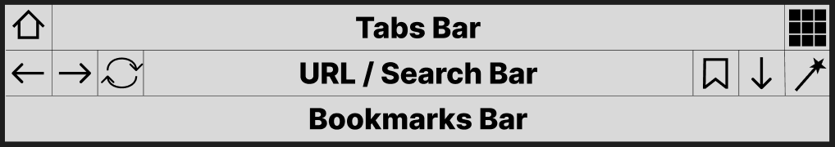

The elements of the taskbar will be as follows (left to right, top to bottom):

- Home Page Button (Navigates user to the browser home page), Tabs Bar (Displays any open tabs the user has), Dashboard Button (Navigates user to the browser dashboard page for their account)
- Back Button (Navigates user back), Forward Button (Navigates user forwards), Reload Button (Refreshes user’s page), URL / Search Bar (Displays user’s current URL and allows them to enter a new search), Bookmark Page Button (Adds current page to the user’s bookmarks bar), Downloads Button (Displays any downloaded files), Settings Button (Navigates user to settings page for browser)
- Bookmarks Bar (Displays user’s bookmarked pages)

At minimum, I want to have all elements of this taskbar implemented and able to perform their tasks. As a stretch task, I want to aim to have all elements of the taskbar be customisable for each user, such as changing the colour, font and size of the taskbar, as well as repositioning each element of the taskbar. The design of the buttons are open to change in the final implementation.

Storyboards:

Flowcharts:
- Home Page:
- Dashboard:
- Taskbar:

Methodology
- Used Electron framework within Visual Studio Code
- Mix of JavaScript, JSON, HTML and CSS
- Had small experience working within these languages before – Used W3Schools to help with code (https://www.w3schools.com/html/default.asp, https://www.w3schools.com/css/default.asp, https://www.w3schools.com/js/default.asp)
- ChatGPT was used for debugging purposes and clarification of language (https://chatgpt.com)
- Used official Electron website and documents (https://www.electronjs.org, https://www.electronjs.org/docs/latest/) to help learn how to implement Electron into this project
- Used Stack Overflow (https://stackoverflow.com/questions) to help with debugging and feature creation

Database
- Needs to store basic user information
- Username, Password, Level, Experience Points, Customisation Settings
- Separate table for customisation with id’s that can link to user table
- Probably use a SQLite database but potentially use Firebase
- Passwords need to be encrypted (use hash)

